Ideation Phase
Brainstorm & Idea Prioritization

Date | 28 January 2026
Team ID000000 | LTVIP2026TMIDS66199
Project Name | TransLingua: AI Powered Multi Language Translator
Maximum Marks | 4 Marks

Brainstorm & Idea Prioritization:
Brainstorming provides a free and open environment that encourages everyone within a team to participate in the creative thinking process that leads to problem solving. Prioritizing volume over value, out-of-the-box ideas are welcome and built upon, and all participants are encouraged to collaborate, helping each other develop a rich amount of creative solutions.
Reference: https://www.mural.co/templates/brainstorm-and-idea-prioritization

Step-1: Team Gathering, Collaboration and Select the Problem Statement

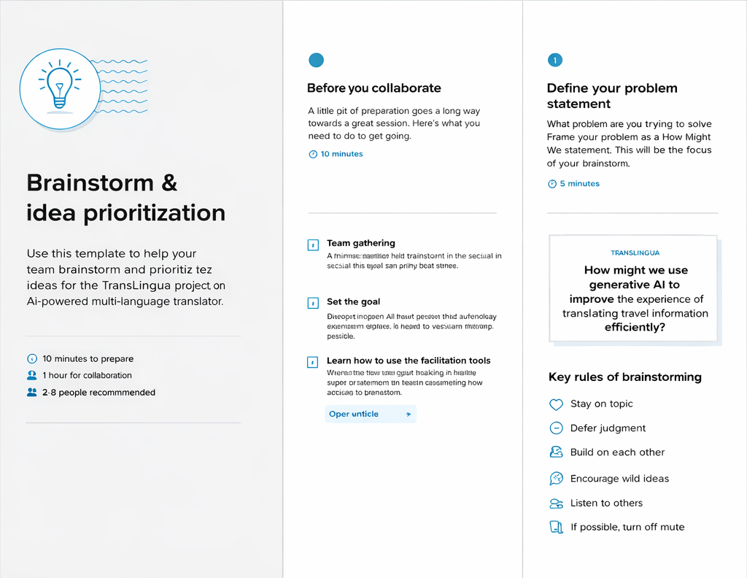
Step-2: Brainstorm, Idea Listing and Grouping

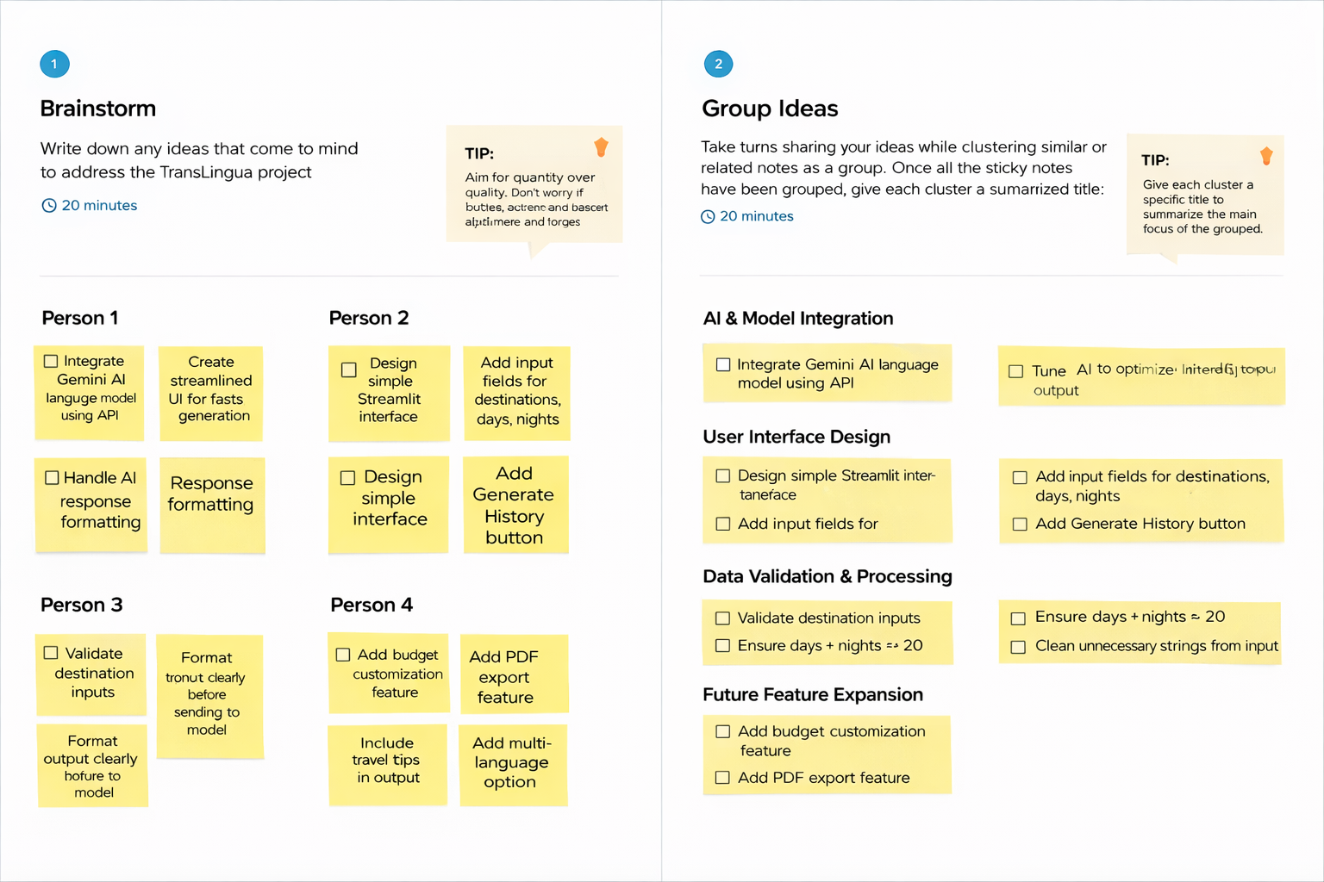

Step-3: Idea Prioritization


